# COS20015 Fundamentals of Data Management

## Workshop 1 & 2 completed tasks

Student Name 104268899

### Workshop 1

**Part 1:**

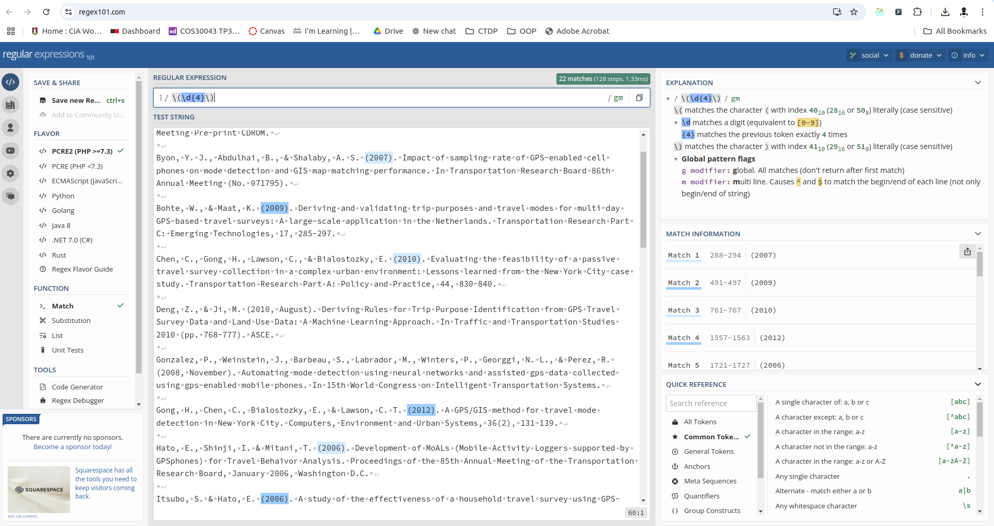

Solution:

\(\d{4}\)

**Part 2:**

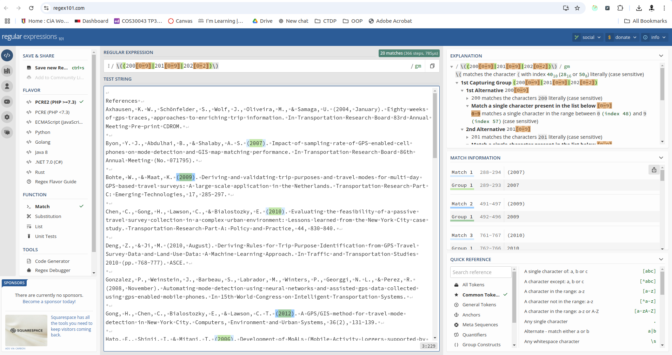Solution: \((200[0-9]|201[0-9]|202[0-2])\)

**Part 3:**

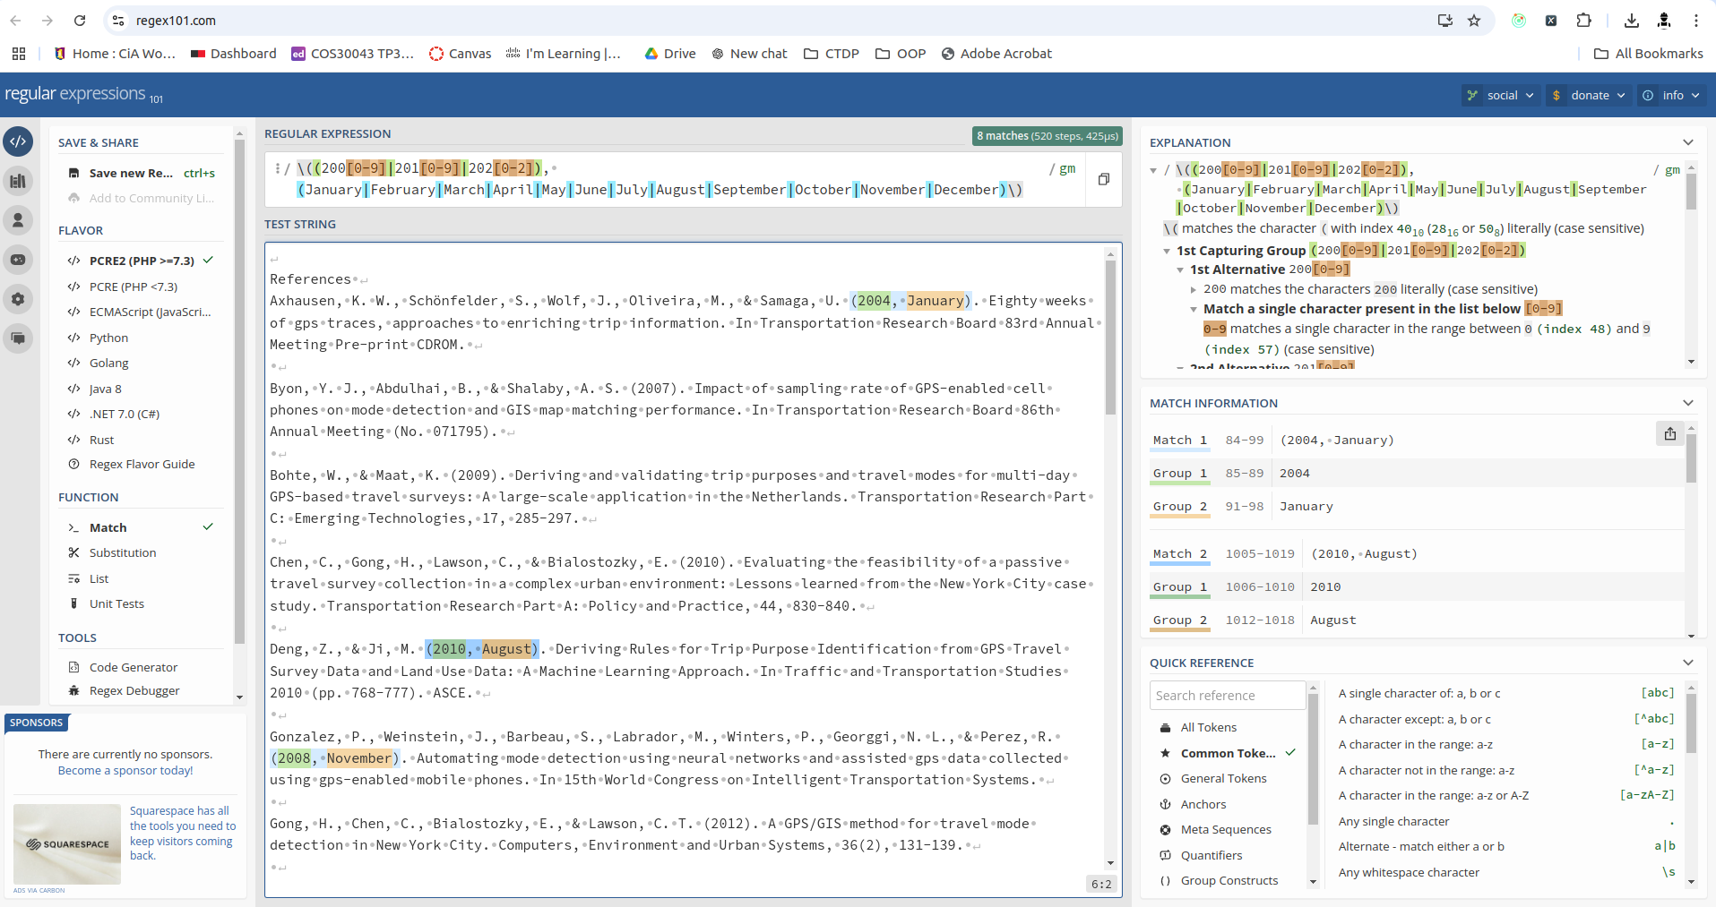

Solution: \((200[0-9]|201[0-9]|202[0-2]), (January|February|March|April|May|June|July|August|September|October|November|December)\)

**Part 4:**

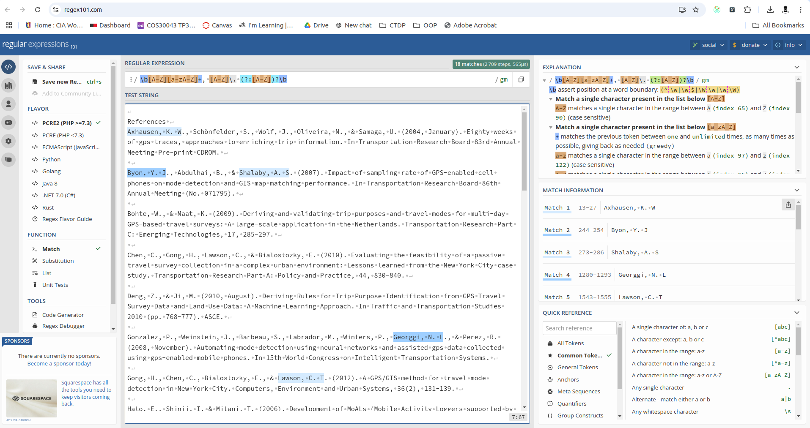Solution: \b[A-Z][a-zA-Z]+, [A-Z]\. (?:[A-Z])?\b

### Workshop 2

**Part 1:**

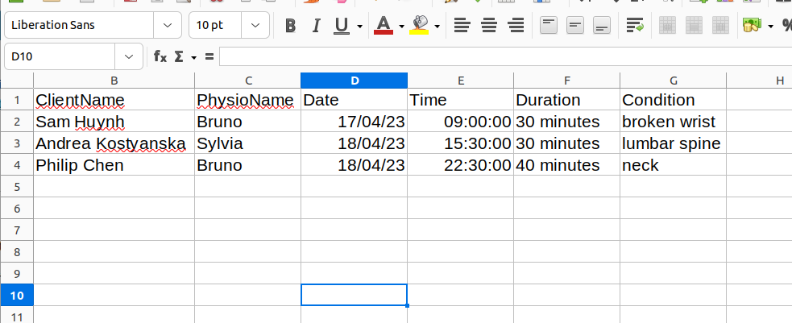

**Part 2:**

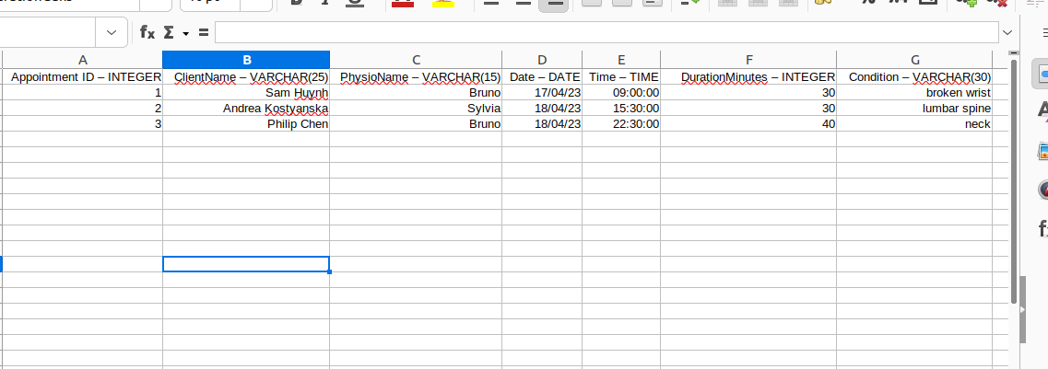

**Part 3:**

